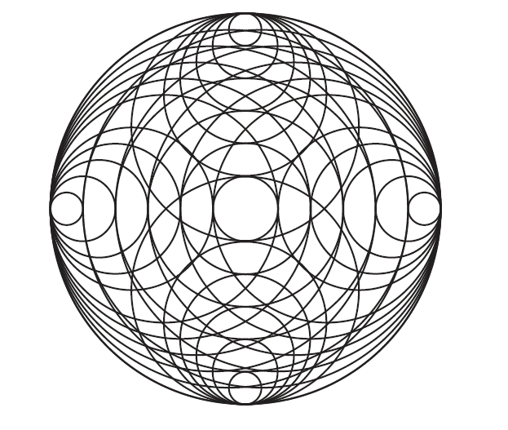
www.centreforpuresound.org
The ‘Angels of Sound’ Sound Healing Training Course Modules.

2 Weekend Modules based in Glastonbury at The Avalon Centre (non-residential)
Autumn 2022
Cost £499/£449 earlybird booking discount-both Modules compulsory.
To register please email ahiahel@live.com

Toning and chanting…is a remarkable practice that allows you to bring into physicality the higher vibrations that stimulate transformation.—Emmanuel

Dean explains:

Hidden at the secret heart of all esoteric practice is the sacred use of sound, and specifically, we believe this to mean the art of Toning and Overtoning. You will be working with the most powerful sound healing tool that exists, one that you don’t have to go out and buy at enormous expense, because it’s, literally, right under your nose—your voice! Our Sound Healing Training is a matter of re-discovering and applying this lost ancient art.

Toning, holding a long note on one vowel-sound, is a deceptively simple yet incredibly powerful cleansing sonic meditation, especially when you consider every sound sacred as we do, and as did the ancients. Applying the sacred vowels of the Sanskrit alphabet then to the chakras is an easily learnt form of musical-meditational practice that can be used daily on oneself or powerfully also in a group to cleanse stabilise and balance the aura and raise personal vibration.

Re-connecting to the Divine Roots of the primal language through honouring the archetype of each sound as an energy in its own right, treating each SOUND as literally an Angel, a Divine Being, which is the case with all originally phonetic sacred alphabets such as Sanskrit and Kuldee, is an indescribably powerful, cleansing, healing practice that absolutely cannot fail as a form of meditation to connect us to our Higher Self.

Having gained confidence is Toning, we then extend this by teaching you the techniques of Overtoning, which is an awesome further level of experience, as it allows you to sound and make audible The Cosmic Scale, the overtone scale/harmonic series, which is inherent yet normally hidden (all that the word ‘occult’ means) in every note you sing or word you speak. The Cosmic Scale is the true Universal Sonic Archetype, from which all sacred geometry and our musical scales, indeed the ratios and proportions and forms of life itself, are derived. This multiplies the vibration-raising effect of toning exponentially.

Every culture has its own style and connected tradition of sacred vocal sound or mantra which works with Divine Names: these names are usually in their essence as described above, a matter of vowel sounds in sequence—without consonants between. These Divine Names are often described as ‘not to be spoken’—this is because they are to be SUNG: toned and overtoned. However most of this knowledge has been lost/suppressed through the ages into the realm of ‘superstition’ (=’that which is left over’), yet it is at the heart of the lost knowledge of spells of the magical traditions of all the 12 tribes and their 12 Keys.

Our Sound Healing Training also works on the principle that we are each in one of these 12 Keys, (the 12, not 8, notes of the scale = 7 white and 5 notes on a piano). We will find the Key Tone for each student, who can work at home on a daily toning practice alongside our Chakra Tones crystal bowls CDs, (one in every key), and ultimately learn to work on clients in the same way. As ever with esoteric work and sound, it is no coincidence that we use the word ‘key’ in musical terms for a base reference note!

MODULE 1

Preliminary session (Friday evening) Power Point presentation—see below.

Angels of Sound (day 1) covers Toning the chakras both freely and alongside our Chakra Tones CDs in your specific Key. Discover your Soul Note (Hara) and Root Tone to then apply the correct pitches personally for your own chakras. We all vibrate all in different keys/at different pitches/rates of vibration and any system that reduces us all to one note (usually ‘C’) does not honour our identity and disparity, our Unity through Diversity.

Shakti Mantra Yoga (day 2) covers Overtoning: how moving between the vowels while still toning on one pitch produces the Pure Sound overtones audibly. The archetype of the 8ve and the mystery of the Major Scale as derived from the overtone scale/harmonic series, The Cosmic Scale.

Chakra dowsing to show level of functioning of chakras, and hara dowsing to establish frequency of Soul Note (hara) and thus Key Tone (for root chakra and thus other chakras up the scale from that root) demonstrated by Dean.

MODULE 2

The Sacred Geometry Of Sound (day 1) covers further refinements with Toning and Overtoning such as learning the Bija Mantras of the elements, toning/overtoning the Skt names of the chakras, overtoning on single vowels/bijas, and multi-syllable Divine Names.

Practitioner Level (day 2) then involves taking the two vocal techniques to the level of healing others, giving a vocal/overtone Pure Sound soundbath alongside our Chakra Tones crystal bowl recordings for vibrational transformation, chakra balancing and energetic healing. You will learn how to identify the client’s Key and how to use a full set of the Chakra Tones CDs, one for each Key.

Chakra dowsing is practised by students in this Module so by this stage student should be equipped with their own pendulum dowser.

Post-Modules: Case Studies
To then qualify as a Practitioner and gain certification you must then submit 5 case studies, four treatments for each case study client (i.e. 20 treatments). There is no time limit for completion and the cycles of Modules repeat allowing for retakes (at a then reduced rate). Obligatory equipment purchase for continuing to case study stage: set of Chakra Tones CDs @ £100.
Our course is accredited by the Isle of Avalon Foundation, Glastonbury.

Power Point delivered on Friday preliminary session and throughout the two course Modules:

The Sacred Geometry of Sound/The Sound Of Sacred Geometry

On our course as well as the practicalities of giving a sound healing 121 treatment using your voice along with the Pure Sound of crystal bowls via our Chakra Tones CDs, you will discover how the overtone scale/harmonic series when realised out loud as pure sound is the Universal Archetype from which all musical scales geometric designs and forms in nature are derived.

Treating each SOUND in a language as literally an Angel, a Divine Being, when SOUND-ing it out loud musically on a sustained note, as is the case with all originally sacred alphabets such as Kuldee and Sanskrit, creates an entirely different, sacred, right-brain, Wisdom-orientated, holistic experience and application of communication through language—which in its left-brain, subject-object forms creates only divisive mis-communication.

Lost (or suppressed?) In Translation

You will also discover how sound work, that is toning and overdoing, is at the heart of all sacred work and traditions, and how the original meanings preserved in writing in the Initiatic Handbooks of various cultures are instructions regarding the practices of the sacred mantras and chants to be sung, toned, and overtoned, written in the imperative tense. This then gets forgotten, or, more likely, deliberately obscured, overlaid with narrative for non-initiates, who take the narratives then to be their literal ‘factual’ tribal history, and the meaning and intent re experiential practices lost.

Then follows the divisive tragedy of ‘religion’ (originally meaning literally ‘to re-connect with the Divine’ –as does ‘yoga’) completely obscuring the original knowledge which was universally understood and shared between cultures.

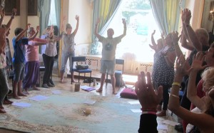

Working with the cakras and the Life Tree of the subtle body through toning, overtoning, and sounding the Divine Names of the QaBaListic, the Gnostic, the Keltic, and the Vedic traditions—reviving the lost esoteric tradition of sonic healing, magic, and science that extends into the past beyond the master Pythagoras and into the healing temples and Initiatic chambers of Egypt, Greece, Albion and Atlantis, and that extends into the future for personal and planetary healing of Gaia and the Kosmos.
Photo: ANGELS OF SOUND voice playshop at Summer Gathering, Wimborne 2014

What some of our previous students have said:

Absolutely brilliant! Wisdom with humour which makes learning so much more of a joy. Toning together as a group was a powerful experience.
I came away inspired and had gained so much new knowledge.
[Dean has] great dedication and desire to pass on healing skills for the greater good.
SB 2018

All of the course was useful and relevant to the subject, incorporating knowledge of the relationship between music and mathematics, sacred geometry, ancient origins of language and original languages such as Sanskrit. Connections between ancient mystical knowledge of Vedas, Tibetan Buddhism, Kabbalah, and Egyptian Mysticism all so relevant and inspiring.
[Dean] has clearly researched and uncovered depths to this topic that can only develop over time form deep passion and interest.
CK 2019

I have enjoyed learning from Dean and taking part in these courses so much. I have found this work totally inspiring. It has reawakened a curiosity in me of all these topics of Ancient Mysticism and Civilisation, Sacred geometry, Overtoning and Sound Healing. It has also started to renew a sense of confidence in using my voice and connecting to music again.
K 2019

... many bits of esoteric info I would be hard pushed to discover elsewhere.
SR 2017

As a tutor Dean is kind, patient, gentle, vastly experienced...and very knowledgeable on all esoteric matters.
CD 2019

...the overtoning practices I found most the most enjoyable. Seems like magic, that part! As a tutor Dean is very knowledgeable and has access to true healing/transformation.
KD 2019

I shall use these techniques in my everyday life, thank you.
SR 2020

Magnificence... Loved it all, it all stood out. Profoundly moving and beautifully evidential....I wish to see your course across the planet!

Thank you for an awesome weekend. Loved it... What I really like is the facts you present from your research, they stick with me, unlike much of the pseudo science from today’s warriors...this was magic and I loved every minute.

Thanks Dean for an awesome experience.
SE 2021

There has been so much value from this course and I found it uplifting and inspiring. Such a patient and gentle tutor with humour and acceptance. The course surpassed my expectations as the information added a whole new perspective.
LM 2021

Dean’s in-depth knowledge is astounding. This work has changed my perception of sound in a profound way.
The practical work is amazing...looking forward to bringing this work to life in my own practice.
TJ 2021

