PSYCHOMUZAK: The Exstasie and Send.

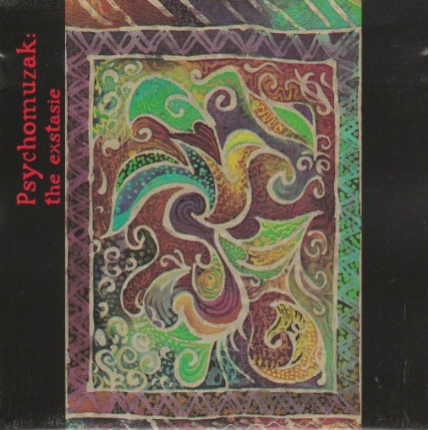

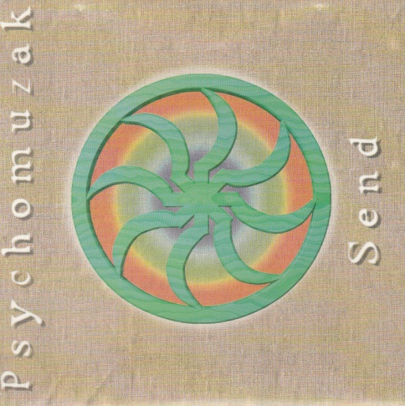

For those of you into rock music, these albums dating from my years as a musician in the 90s represent a crossover between ‘normal’ music/listening experiences and our current Pure Sound therapy work and are available exclusively from us, the record labels they were originally released on having become defunct.

Based around my experimental effect-based electric guitar work, I found that this sort of work was taking me into a borderline area of healing sound, the repeating patterns generated by echo-effects, for example, becoming almost mantra like, and much of the work being based on drones washes and textures of sound. I coined the term PSYCHOMUZAK for this project to distinguish it from my work as a singer-songwrter.

Once I’d become ill with CFS in the late 90s I put my whole previous life as a musician behind me—not being able to play or even listen to music, there wasn’t much choice—and embraced the only possible avenue of continuing existence, a somewhat ascetic spiritual path.

However at some point as the label they were on was going under I bought the last stocks of my own first Psychomuzak album The Exstasie and realised there was indeed a healing element to the work, confirmed by my guidance, which assured me that that the 5 tracks were in fact a journey deeper and deeper through the 5 kośas or layers of the aura (related to the chakras).

Starting with the title track which even might be ‘danceable’ and relates to 1st layer (Physical body and Earth element), we then descend via the 2nd track using a ‘shamanic’ drumming motif in 7/8 (non-dancey yet still rhythmic) called ‘Diamond Zombie’ (itself a term from Tibetan Buddhism) to the level of the variously entitled ‘energetic/etheric/subtle body’ of the chakras and aura as a whole.

The 3rd layer using both guitar and Hurdy-Gurdy played by friend and collaborator Cliff Stapleton is appropriately enough entitled ‘Far In’, taking us into the Astral Body.

Melody, Harmony etc. are abandoned by the next track ‘Concentrate’ and layer, the Mental Body—eventually some rhythm emerges from this sustained meditative drone/wash. While finally the pure drone of ‘Concentration’ takes us to the final sheath of the kośas, the Causal Body, which also enfolds the higher Atmic and Buddhic bodies.

This last track I had to fight with the producer to keep on, as ‘nothing is happening’—but that’s exactly the point, it represents the No-Thing-Ness of The Void, the Pleroma, the contradictory Emptiness-Enfolding-Fullness, of the final stages of meditative experiences. I found listening to this ‘mere’ backing-track drone actually very healing and nourishing—and now know why. The repeated guitar echo patterns were in fact generating Pure Sound overtones in this track—the very existence of which knew nothing about at the time (1994). Similarly I knew nothing regarding our theory of everyone being in their own particular key—‘Concentration’ turns out to be on my own hara note.

The second Psychomuzak album also has strong healing ‘overtones’ you might say, and I’m now making copies of this available to interested parties. A more widescreen effort involving other musicians (notably ex-King Crimson violinist David Cross, most of the band Mandragora including Simon Williams, and ex-Camel and Marillion drummer Andy Ward) the long instrumental tracks also embody a long journey or series of journeys.

Keep Breathing was inspired by my own very powerful but often difficult experiences of Holotropic Breathwork, so this is quite a stormy and uncomfortable journey involving as it did reliving past (and even past-life) traumas, then moving through into a sense of triumph and transcendence.

Deep Heat starts in the dub-zone, then zooming off into again quite a hectic space or journey, before returning to the home key (D again) and more relaxed pulse and feel.

Send the title track is a major journey in itself in an absolute void to begin with in terms of key and pitching. Eventually resolving into a 5/4 tribal pulse, this track actually features in its soundscape washes an overtoning choir now adding a stabilising element of pitch (E). The pulse then doubles and a second section and main riff features the virtuoso playing of David Cross in very Eastern mode with lots of harmonics (overtones).

Sea of Tranquility ends the album with a sense of return to ‘safe harbour’ and is the only piece not to use a rhythm section.

While we’ve had copies of The Exstasie with us at soundbaths seemingly forever, (priced as per the Divine Union Soundbath), the 2nd Psychomuzak album Send vanished even more fully without trace with the demise of the original label, which is a shame. I’ve determined until something can be done about this legally to provide (semi self-bootleg) copies to interested parties—suggested donation £12 + £2.50.

